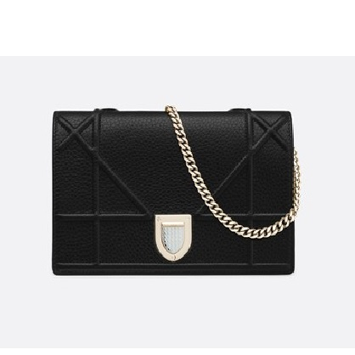

Diorama calfskin clutch

PRODUCT DETAILS

**Large "Cannage" design topstitching**

**Crest-shaped clasp, removable chain and jewellery in light gold-tone metal**

**Tone-on-tone lambskin lining**

**Large inner compartment**

**4 card slots**

**1 flat pocket**

**1 zipped pocket**

**Carried in the hand, on the shoulder or across the body**

**Dimensions: 19 x 12 x 3 cm**

**Chain: 120 cm**